Little SPARK: Simple Play Adaptations to Reference for Kids

PowerLink 4
Description: | Image:
The PowerLink 4 is a switch interface that enables electrical appliances/devices to be controlled with switches either wired or wireless. One or two devices can be plugged into the PowerLink and either one or two switches can be used to activate the devices. There are 6 different modes of control. | 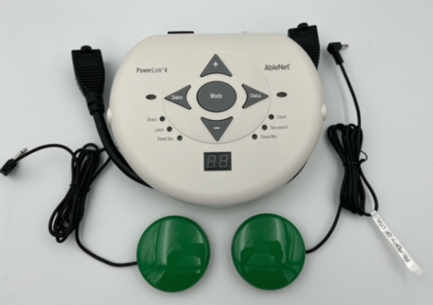

Who Might Benefit?
Those who benefit from switch use or currently use switches as an access method because they are unable to access typical classroom activities or common electrical appliances.
Why Use?
Provides an opportunity to activate an appliance for participation in classroom activities, i.e. cooking, music, math, literacy, etc.
Instructions for Use: | Adaptation Ideas:
Environmental Considerations  - Use on any flat surface with easy access to an electrical outlet.  Positioning & Alternate Positioning  - Use in any position where the device and switches are accessible.  Basic Play/Use  - Plug the PowerLink into any AC wall outlet and power on.  - Plug appliance into either power cable on the PowerLink and turn the appliance on.  - Attach and switches to corresponding switch jack(s).  Extended Play/Use  - Five other modes are available and useful for a variety of reasons. These can be activated by pressing the mode button in the middle of the device until the desired mode type is located.  Play/Use with Others  - The “Two-switch” mode provides an opportunity for a child to engage in collaborative/cooperative play with another child or adult since pressing both switches are required to activate the appliance/device. | Optional Additional Materials/Supplies  - Velcro  - Dycem, non-skid matting, cabinet liner  Stabilize It  - Stabilize on a flat surface with either Velcro or a non-skid matting such as Dycem or cabinet liner.  Add Sensory Cues  - Add textures, colors, or picture symbols combined with words could be added to the switches.  Communication Support  - Include communication boards with keywords needed to engage in the specific activity.  Alternative Uses  - Trial multiple types of switches.

Words to Encourage Play/Use
More  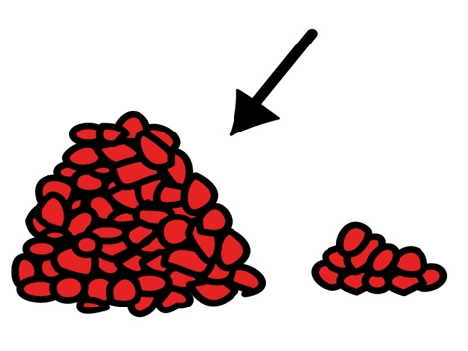 | Go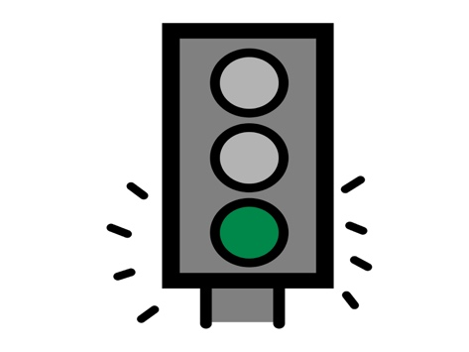 | Help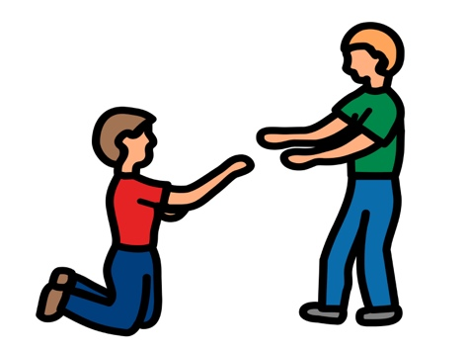
Push | Stop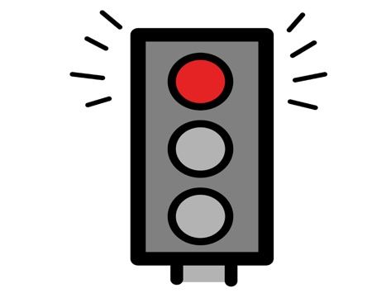 | Ready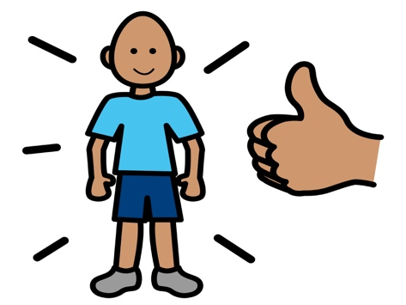
On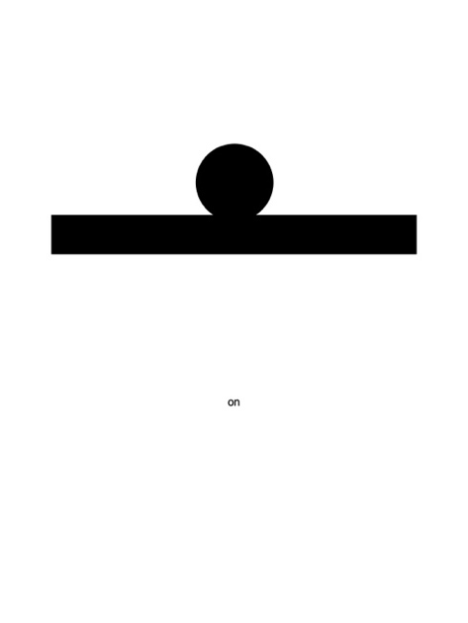 | Off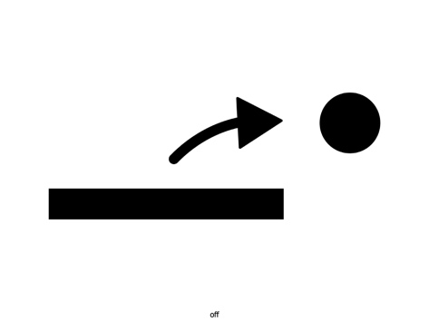 | Done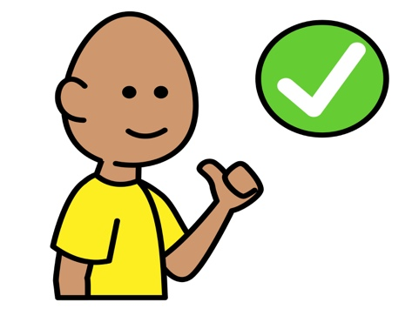
*”Adaptations” adapted from: Haugen’s Modes for Adapting Toys based on materials from the "Let's Play" Project at the University of Buffalo
PCS is a trademark of Tobii Dynavox, LLC. All rights reserved. Used with permission.

